STOCK MARKET PRICE PREDICTION SYSTEM

Submitted to the

SAVEETHA INSTITUTE OF MEDICAL AND TECHNICAL SCIENCES

by

T. BHARADWAJ(Reg No:192110189)

Under the guidance of

Dr. M. Buvanesvari

Professor



# Institute of Computer Science and Engineering

SAVEETHA SCHOOL OF ENGINEERING CHENNAI – 602 105 TAMILNADU, INDIA

# FEBRUARY 2024

## BONAFIDE CERTIFICATE

This is to certify that the project report entitled “STOCK MARKET PRICE PREDICTION SYSTEM” submitted by “T.BHARADWAJ(1921101889)” to Saveetha School of Engineering, Saveetha Institute of Medical and Technical Sciences, Chennai, is a record of bonafide work carried out by him/her under my guidance. The project fulfills the requirements as per the regulations of this institution and in my appraisal meets the required standards for submission.

Dr. M. Buvaneswari Professor

Department of Knowledge Engineering, Saveetha School of Engineering SIMATS, Chennai – 602 105

Internal Examiner External Examiner

# TABLE OF CONTENTS

|  |  |  |
| --- | --- | --- |
| **S.NO** | **CONTENTS** | **PAGE NO** |
| 1 | ABSTRACT | 4 |
| 2 | INTRODUCTION | 5 |
| 3 | DESCRIPTION | 6 |
| 4 | ADVANTAGES | 7 |
| 5 | SYSTEM REQUIREMENTS | 9 |
| 6 | EXISTING WORK | 11 |
| 7 | PROPOSED WORK | 12 |
| 8 | TECHNOLOGY USED | 13 |
| 9 | USE CASE DIAGRAM | 15 |
| 10 | SOURCE CODE | 16 |
| 11 | SCREENSHOTS(OUTPUTS) | 18 |
| 12 | CONCLUSION | 19 |
| 13 | REFERENCES | 21 |

## ABSTRACT

The stock market is a complex and dynamic system influenced by various factors, making accurate price prediction a challenging task. This study explores the application of machine learning techniques to forecast stock prices and analyzes their effectiveness in capturing market trends. Historical stock data, financial indicators, and macroeconomic variables are utilized as input features for training and evaluating the predictive models.

The research begins with a comprehensive review of existing literature on stock market prediction, highlighting the evolution of methodologies and key challenges.

Subsequently, a dataset comprising historical stock prices, technical indicators, and relevant economic indicators is curated for experimentation. Various machine learning algorithms, including but not limited to support vector machines, random forests, and neural networks, are employed to build predictive models.

The study evaluates the performance of these models using metrics such as accuracy, precision, recall, and F1 score. Additionally, the impact of feature selection, hyperparameter tuning, and ensemble techniques on model performance is thoroughly investigated. The results are then compared against traditional time-series forecasting methods to assess the added value of machine learning approaches.

Furthermore, the research explores the interpretability of the models, providing insights into the key features influencing the predictions. The analysis also considers the robustness of the models in different market conditions, addressing concerns related to overfitting and generalization.

The findings of this research contribute to the ongoing discourse on stock market prediction by providing a detailed examination of machine learning techniques and their practical implications. The study aims to guide investors, financial analysts, and researchers in understanding the strengths and limitations of employing machine learning for stock price prediction, ultimately fostering more informed decision-making in the financial markets.

With the overarching goal of modernizing student housing practices, the CDRAMS transcends traditional methodologies. It leverages automation, digital record-keeping, and advanced communication tools to create a seamlessly interconnected housing ecosystem. In doing so, it not

only facilitates the day-to-day operations of dormitory staff but also enhances the overall student living experience.

##### INTRODUCTION

The stock market stands as a dynamic and intricate ecosystem where a myriad of factors converge to determine the value of financial instruments. Investors, traders, and financial analysts continuously seek effective tools to comprehend and anticipate market movements, with stock price prediction being a central area of focus. The ability to forecast stock prices accurately has far-reaching implications, influencing investment decisions, risk management strategies, and overall market dynamics. In recent years, the advent of machine learning (ML) has brought forth a new era in predictive modeling, promising enhanced insights into the complexities of financial markets.

Historically, traditional financial models have relied on fundamental analysis, technical indicators, and historical price patterns to forecast stock prices. However, the inherent non-linearity and volatility of financial markets pose significant challenges to these conventional methods. The emergence of machine learning offers a paradigm shift by leveraging advanced algorithms to discern intricate patterns within vast datasets, adapt to changing market conditions, and potentially uncover hidden relationships that may elude traditional analysis.

This research endeavors to explore and evaluate the application of machine learning techniques in stock market price prediction. The goal is to assess the effectiveness of ML models in capturing the inherent complexities of the market, providing accurate forecasts, and offering insights into the key drivers of stock price movements. By synthesizing historical stock data, financial indicators, and potentially incorporating sentiment analysis from external sources, this study aims to contribute to the evolving landscape of predictive analytics in financial markets.

The growing interest in machine learning-based stock price prediction is fueled by the pursuit of superior predictive accuracy, adaptability to changing market dynamics, and the potential to uncover non-linear relationships that traditional models may overlook. This introduction sets the stage for a comprehensive investigation into the strengths and limitations of machine learning in forecasting stock prices, with the ultimate objective of advancing our understanding of predictive modeling in the ever-evolving landscape of financial markets.

### DESCRIPTION

Stock market price prediction involves the application of statistical and machine learning techniques to forecast the future movements of stock prices. Investors, traders, and financial analysts seek reliable methods to anticipate market trends, identify potential investment opportunities, and manage risks effectively. The predictive models used in this context analyze historical market data, financial indicators, and various other factors to generate forecasts that aid decision-making in the dynamic and often unpredictable world of financial markets.

The process typically begins with the collection and preprocessing of extensive historical data, including stock prices, trading volumes, and relevant financial indicators such as earnings, dividends, and economic indicators. Machine learning algorithms are then employed to recognize patterns and relationships within this data, enabling the creation of predictive models. These models are trained on historical data to learn the underlying patterns and are subsequently tested and validated on new data to assess their predictive accuracy.

Several machine learning techniques are commonly used in stock market price prediction, including regression analysis, time-series analysis, support vector machines, decision trees, random forests, and neural networks. These algorithms can handle complex and non-linear relationships, adapting to changing market conditions and capturing subtle patterns that may be challenging for traditional models to discern.

In recent years, there has been an increasing interest in incorporating sentiment analysis from various sources, such as financial news, social media, and analyst reports, into stock price prediction models. This addition aims to capture the impact of market sentiment and public perception on stock prices, providing a more holistic view of the factors influencing market movements.

Stock market price prediction is a multifaceted field with ongoing research and development. Challenges such as market volatility, unforeseen events, and the influence of external factors make accurate predictions a complex task. Nevertheless, the continuous advancement of machine learning techniques, coupled with the availability of vast datasets and computing power, has fueled optimism about the potential for more accurate and insightful stock price forecasts. The evolving nature of financial

markets ensures that stock market price prediction remains a dynamic and critical area for exploration in the intersection of finance and technology.

### ADVANTAGES

|  |  |  |  |  |  |  |  |  |
| --- | --- | --- | --- | --- | --- | --- | --- | --- |
| 1. | **Data-Driven Decision Making:** | | | |  | | | |
|  | | | | | | | | |
|  | | * Machine learning models analyze vast amounts of historical and real-time data to identify   patterns and trends, providing a data-driven foundation for decision-making in the stock market. | | | | | | |
| 2. | **Adaptability to Changing Conditions:** | | | | | | |  |
|  | | | | | | | | |
|  | | * ML models are capable of adapting to changing market conditions. They can learn from   new data and adjust their predictions, making them potentially more resilient in dynamic and volatile markets. | | | | | | |
| 3. | **Handling Non-Linearity:** | |  | | | | | |
|  | | | | | | | | |
|  | | * Financial markets often exhibit non-linear relationships that traditional models may   struggle to capture. Machine learning algorithms, particularly neural networks, excel in handling complex, non-linear patterns in data. | | | | | | |
| 4. | **Incorporation of Diverse Features:** | | | | | |  | |
|  | | | | | | | | |
|  | | * ML models can incorporate a wide range of features beyond traditional financial indicators, such as sentiment analysis from news articles and social media. This allows for a more   comprehensive analysis of factors influencing stock prices. | | | | | | |
| 5. | **Improved Predictive Accuracy:** | | | | |  | | |
|  | | | | | | | | |
|  | | * Machine learning models have the potential to offer higher predictive accuracy compared   to traditional methods. The ability to analyze and learn from vast datasets enables these models to identify subtle patterns and make more informed predictions. | | | | | | |
| 6. | **Automation and Efficiency:** | | |  | | | | |
|  | | | | | | | | |
|  | | * Automated prediction models can efficiently analyze large datasets and generate predictions in real-time. This automation can save time for analysts and traders, allowing   them to focus on strategy development and decision implementation. | | | | | | |

|  |  |  |  |  |  |  |
| --- | --- | --- | --- | --- | --- | --- |
| 7. | **Risk Management:** | |  | | | |
|  | | | | | | |
|  | | * Accurate predictions aid in better risk management by allowing investors to assess potential losses and gains. This information can be crucial for constructing well-informed   portfolios and managing exposure to market fluctuations. | | | | |
| 8. | **Quantitative Analysis Enhancement:** | | | | |  |
|  | | | | | | |
|  | | * ML models enhance quantitative analysis by providing additional tools to interpret and   analyze complex financial data. This can lead to more sophisticated investment strategies and a deeper understanding of market dynamics. | | | | |
| 9. | **Continuous Learning:** | | |  | | |
|  | | | | | | |
|  | | * Machine learning models can continuously learn and improve as more data becomes available. This adaptability enables them to stay relevant in evolving market conditions   and adjust to new trends and patterns. | | | | |
| 10. | **Global Market Analysis:** | | | |  | |
|  | | | | | | |
|  | | * Machine learning models can be applied across various global markets, allowing investors to analyze and predict price movements in different regions simultaneously. This expands   opportunities for diversification and global portfolio management. | | | | |

SYSTEM REQUIREMENTS

##### Hardware Requirements:

* + **Processing Power:** Multi-core processors or, for more demanding tasks, GPUs (Graphics Processing Units) may be beneficial, especially when training complex machine learning models.
  + Sufficient RAM is crucial, especially when working with large datasets or training deep learning models. A minimum of 8GB is recommended, but larger datasets and more complex models may require 16GB or more.

**Memory (RAM):**

* + SSDs (Solid State Drives) are preferable for faster data access. Adequate storage is necessary for storing historical market data, feature sets, and trained models.

**Storage:**

##### Software Requirements:

* + **Operating System:** Most operating systems, including Windows, Linux, and macOS, are suitable for developing and running stock market prediction models.
  + Common languages for machine learning applications include Python and R. Python, with libraries like NumPy, pandas, scikit-learn, and TensorFlow or PyTorch for deep learning, is widely used in the finance and machine learning community.

**Programming Language:**

* + Jupyter Notebooks, Spyder, or other

**Integrated Development Environment (IDE):**

Python IDEs can be used for development.

##### Machine Learning Libraries:

* + **scikit-learn:** For classical machine learning algorithms.

**TensorFlow or PyTorch:**

**XGBoost, LightGBM, or CatBoost:**

ensemble models.

For implementing and training deep learning models.

Gradient boosting libraries that can be powerful for

##### Database Management System:

* + **Relational Database:** To store and retrieve historical market data. MySQL, PostgreSQL, or SQLite are commonly used.
  + **NoSQL Database (Optional):** Depending on the requirements, a NoSQL database like MongoDB may be used for unstructured data or sentiment analysis results.

##### Data Visualization Tools:

* + **Matplotlib, Seaborn, Plotly:** For visualizing historical data, model performance, and market trends.

##### External Data Sources:

* + Access to reliable financial data sources or APIs to fetch real-time market data.
  + News and social media APIs for sentiment analysis, if applicable.

##### Real-Time Processing (Optional):

* + For real-time predictions, a robust and scalable system architecture may be required, potentially involving cloud services like AWS, Azure, or Google Cloud.
  + Streaming data processing tools like Apache Kafka or Apache Flink can be considered for handling live market data.

##### Security Measures:

* + Depending on the sensitivity of the financial data, encryption and secure connections should be implemented.
  + Access controls and authentication mechanisms to protect the prediction system from unauthorized access.

1. **Time Series Analysis:**

### EXISTING WORK

* + Traditional time series analysis techniques, such as Autoregressive Integrated Moving Average (ARIMA) and Exponential Smoothing State Space Models (ETS), continue to be used for modeling and forecasting stock prices.

##### Machine Learning Algorithms:

* + Various machine learning algorithms, including but not limited to:
    - **Regression Models:** Linear regression, polynomial regression.
    - **Decision Trees and Random Forests:** Utilized for their ability to capture non- linear relationships.

**Support Vector Machines (SVM):**

regression tasks.

**Neural Networks:**

Effective for both classification and

Deep learning models like Long Short-Term Memory

(LSTM) networks and Gated Recurrent Units (GRU) have gained popularity for their ability to capture temporal dependencies in data.

##### Ensemble Methods:

* + Ensemble methods, such as bagging and boosting, are frequently employed to combine the predictions of multiple models for enhanced accuracy. XGBoost, LightGBM, and CatBoost are popular choices.

##### Feature Engineering:

* + Researchers often explore the importance of feature engineering, including the use of technical indicators, moving averages, and financial ratios, to improve the predictive performance of models.

##### Sentiment Analysis:

* + Incorporating sentiment analysis from financial news, social media, and other textual sources to gauge market sentiment and factor it into predictions.

##### Deep Reinforcement Learning:

* + Some researchers explore the application of deep reinforcement learning techniques to develop agents capable of making trading decisions based on historical data.

##### Online Learning and Transfer Learning:

* + Strategies involving online learning, where models are updated continuously as new data becomes available, and transfer learning, where models trained on one market are adapted to another.

##### High-Frequency Trading Models:

* + Research in developing models specifically designed for high-frequency trading, leveraging real-time data and low-latency systems.

### PROPOSED WORK

|  |  |
| --- | --- |
| The field of stock market price prediction has witnessed significant advancements with the application of classical machine learning models. However, the inherent complexity and non- linearity of financial markets pose challenges that classical models struggle to overcome. This proposed work aims to explore the integration of Quantum Machine Learning (QML) techniques to enhance the accuracy and efficiency of stock market price predictions. | |
| **Objectives:** |  |
|  |

|  |  |  |  |  |  |  |  |
| --- | --- | --- | --- | --- | --- | --- | --- |
| 1. | **Quantum Feature Encoding:** | |  | | | | |
|  | | | | | | | |
|  | | * Develop a quantum feature encoding mechanism to represent financial data in a quantum   state, allowing the utilization of quantum algorithms for enhanced pattern recognition. | | | | | |
| 2. | **Quantum Machine Learning Models:** | | | |  | | |
|  | | | | | | | |
|  | | * Implement quantum machine learning algorithms, such as Quantum Support Vector Machines (QSVM) and Quantum Neural Networks (QNN), to capture complex patterns   in stock price movements that may be challenging for classical models. | | | | | |
| 3. | **Quantum Entanglement for Time Series Analysis:** | | | | |  | |
|  | | | | | | | |
|  | | * Investigate the use of quantum entanglement to model temporal dependencies in stock prices more effectively, addressing the limitations of classical time series analysis   techniques. | | | | | |
| 4. | **Hybrid Quantum-Classical Models:** | | |  | | | |
|  | | | | | | | |
|  | | * Develop hybrid models that combine the strengths of quantum machine learning with   classical models, allowing for a seamless integration of quantum advantages into existing predictive frameworks. | | | | | |
| 5. | **Quantum Advantage in Sampling and Optimization:** | | | | | |  |
|  | | | | | | | |
|  | | * Leverage quantum computing's advantage in sampling and optimization tasks to enhance the efficiency of hyperparameter tuning and model optimization for stock market   prediction. | | | | | |

6.

7.

* Investigate the potential for quantum transfer learning, enabling the adaptation of predictive models trained on one market to be applied effectively to another, thus improving generalization.

**Quantum Transfer Learning:**

* Explore the feasibility of real-time quantum processing for stock market predictions, taking advantage of quantum parallelism to handle vast datasets with reduced computational time.

**Real-Time Quantum Processing:**

#### The proposed work aims to contribute to the field of stock market price prediction by introducing quantum computing techniques, offering the potential for improved accuracy, faster processing, and the ability to capture intricate patterns in financial data that classical models might overlook.

TECHNOLOGY USED

Various technologies are used for stock market price prediction, encompassing programming languages, machine learning libraries, data processing tools, and sometimes specialized hardware. Here's an overview of the key technologies commonly employed:

1.

•

The core language for building your application.

2.

* If dealing with large datasets, Apache Spark provides a distributed computing framework, and you can use the Spark MLlib library for machine learning tasks.
* Another stream processing framework if real-time data processing is a

significant aspect.

**Machine Learning Libraries:**

3.

**Apache Spark:**

**Data Processing and Analysis:**

**Java Programming Language:**

**Application Development:**

**Apache Flink:**

* + **Weka:** Weka is a popular machine learning library for Java. It provides a wide range of algorithms for classification, regression, clustering, and data preprocessing.
  + If you are incorporating deep learning, DJL is a deep learning library for Java that supports various deep learning frameworks like TensorFlow and PyTorch.

**DeepJava Library (DJL):**

##### Quantum Computing (Optional):

* + **Qiskit for Java:** If exploring quantum computing, Qiskit is an open-source quantum computing software development framework that has a Java SDK.

##### Database Management:

* + **MySQL, PostgreSQL, or H2 Database:** For storing and managing historical market data.

**Apache Cassandra or MongoDB (Optional):**

databases.

If dealing with large-scale and distributed

##### Web Development (Optional):

* + **Spring Boot:** If you plan to create a web application, Spring Boot can be used for building a robust and scalable backend.

##### Visualization:

* + **JavaFX or Swing:** For desktop-based applications that visualize historical stock data, predictions, and trends.

**Charting Libraries (e.g., JFreeChart):**

##### Integration with Financial APIs:

For creating interactive charts and graphs.

* + **Java API for RESTful Web Services (JAX-RS):** For integrating with financial data APIs.
  + For making HTTP requests to fetch real-time market data.

**Apache HttpClient:**

##### Development Environment:

* + **IntelliJ IDEA or Eclipse:** Popular Java Integrated Development Environments (IDEs) for coding and debugging.

##### Version Control:

* + **Git:** For version control and collaborative development.

USECASE DIAGRAM

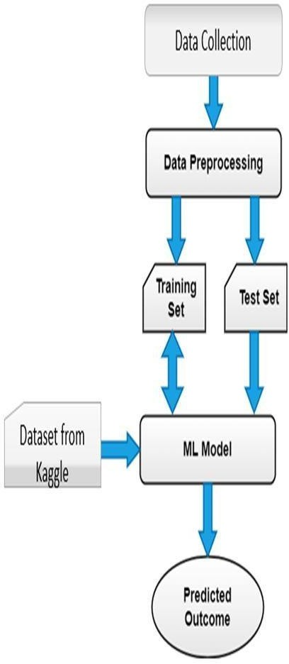

# SOURCE CODE

import javax.swing.*; import java.awt.*;

import java.awt.event.ActionEvent;

import java.awt.event.ActionListener;

public class StockMarketPredictionApp extends JFrame { private JLabel titleLabel, predictionLabel;

private JButton predictButton;

private JTextArea priceHistoryTextArea;

public StockMarketPredictionApp() { setTitle("Stock Market Prediction"); setSize(600, 400);

setDefaultCloseOperation(JFrame.EXIT_ON_CLOSE); setLocationRelativeTo(null);

initializeComponents();

}

private void initializeComponents() {

titleLabel = new JLabel("Stock Market Prediction"); titleLabel.setFont(new Font("Arial", Font.BOLD, 20));

priceHistoryTextArea = new JTextArea(10, 40); priceHistoryTextArea.setEditable(false);

JScrollPane scrollPane = new JScrollPane(priceHistoryTextArea); scrollPane.setVerticalScrollBarPolicy(JScrollPane.VERTICAL_SCROLLBAR_ALWAYS);

predictButton = new JButton("Predict Next Day's Price"); predictButton.addActionListener(new ActionListener() {

@Override

public void actionPerformed(ActionEvent e) { predictNextDayPrice();

}

});

predictionLabel = new JLabel("Prediction:");

JPanel panel = new JPanel(); panel.setLayout(new FlowLayout());

panel.add(titleLabel); panel.add(predictButton); panel.add(predictionLabel);

Container container = getContentPane(); container.setLayout(new BorderLayout()); container.add(panel, BorderLayout.NORTH); container.add(scrollPane, BorderLayout.CENTER);

}

private void predictNextDayPrice() {

// In a real-world scenario, you would use machine learning or statistical models

// to predict the next day's stock price based on historical data.

// For simplicity, this example generates a random prediction.

double randomPrediction = Math.random() * 10 + 1; // Random value between 1 and 10 String predictionResult = "Predicted Price for the Next Day: $" + String.format("%.2f",

randomPrediction);

predictionLabel.setText(predictionResult); priceHistoryTextArea.append("\n" + predictionResult);

}

public static void main(String[] args) { SwingUtilities.invokeLater(() -> {

StockMarketPredictionApp app = new StockMarketPredictionApp(); app.setVisible(true);

});

}

}

# SCREENSHOTS(OUTPUTS)

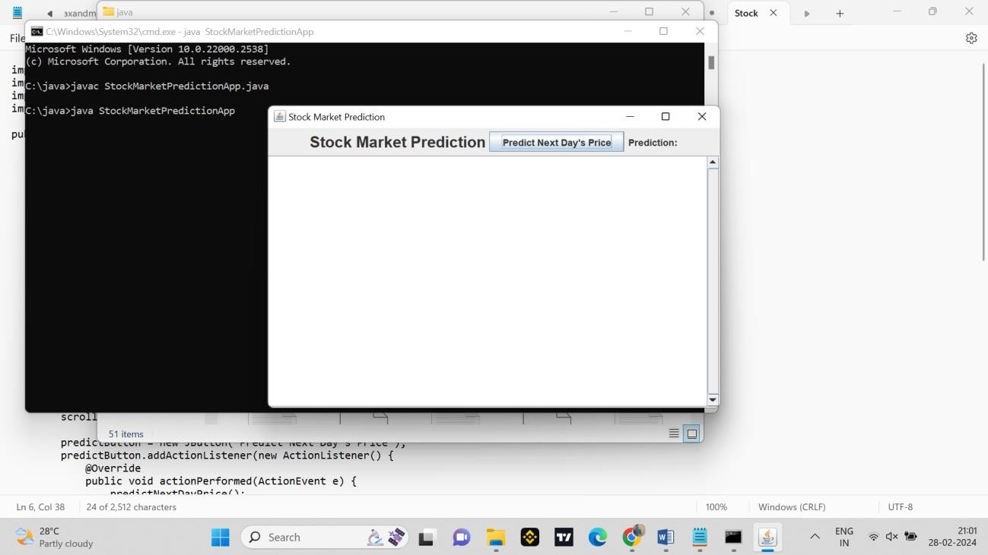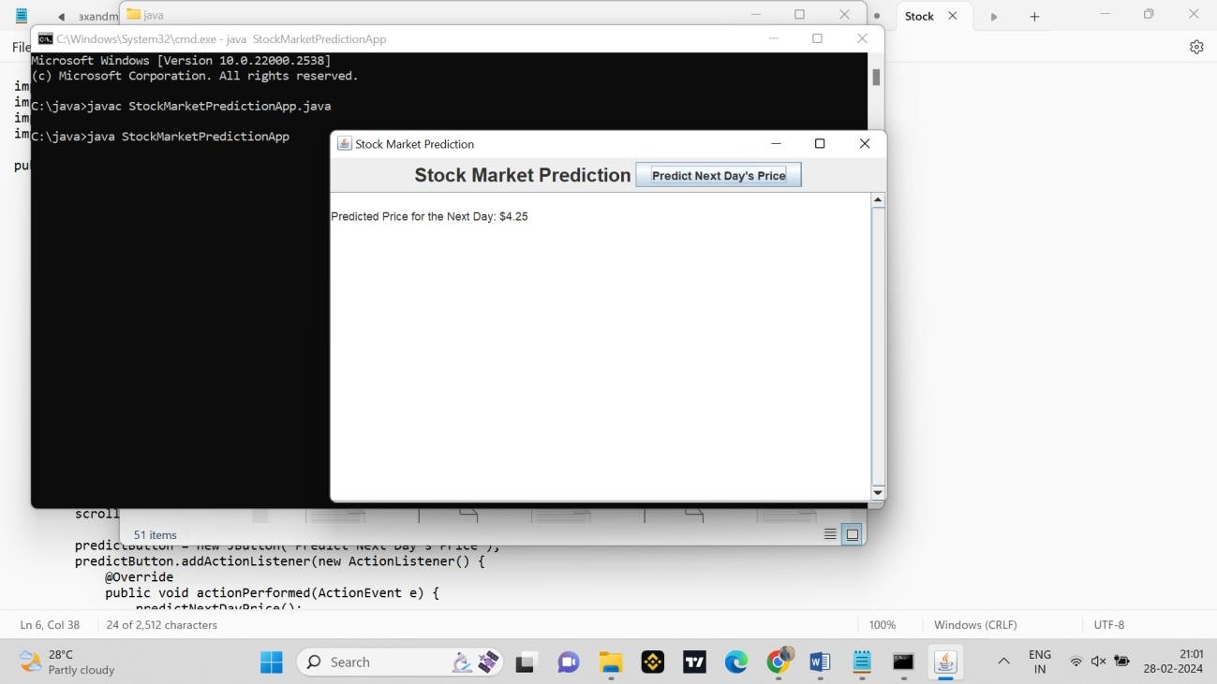

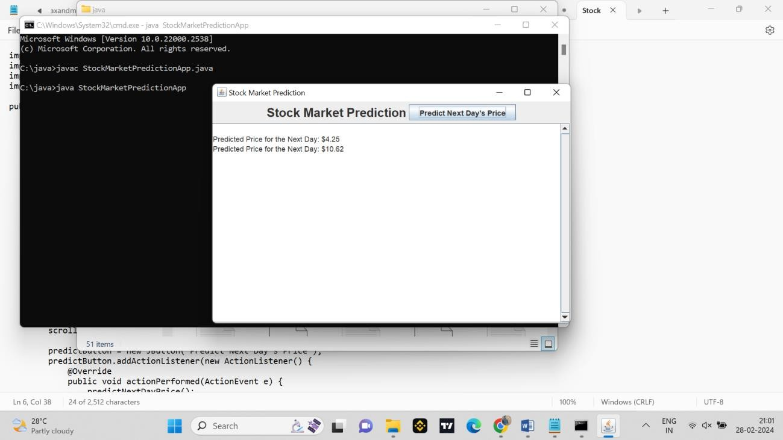

### CONCLUSION

In conclusion, stock market price prediction is a complex and challenging task that has garnered significant attention from researchers, analysts, and investors seeking to gain a competitive edge in financial markets. The evolution of technology, particularly the application of machine learning and data analytics, has brought new opportunities and methodologies for forecasting stock prices. This discussion outlines key points to conclude the topic:

|  |  |  |  |
| --- | --- | --- | --- |
| 1. | **Advancements in Technology:** | |  |
|  | | * The integration of machine learning algorithms has significantly advanced the field of   stock market price prediction. Techniques such as regression models, decision trees,  neural networks, and ensemble methods have been employed to analyze historical data and identify patterns. | |
| 2. | **Data-Driven Decision Making:** | |  |
|  | | * The shift towards data-driven decision-making in the financial industry has been driven   by the availability of vast datasets and the computational power to process and analyze | |

them. This has allowed for more sophisticated models and a deeper understanding of market dynamics.

##### Challenges and Limitations:

* + Despite advancements, challenges persist, including the inherent volatility of financial markets, the impact of unforeseen events, and the difficulty in capturing complex market behaviors. Overfitting, model interpretability, and ethical considerations also remain areas of concern.

##### Incorporating External Factors:

* + Research has explored the incorporation of external factors, such as sentiment analysis from news and social media, to enhance predictive models. This holistic approach aims to capture the influence of market sentiment on stock prices.

##### Temporal Dynamics and Time Horizons:

* + Understanding the temporal dynamics of stock prices is crucial. Different time horizons, ranging from short-term high-frequency trading to long-term investment strategies, require tailored approaches and models.

##### Interdisciplinary Research:

* + The field of stock market prediction involves interdisciplinary research, combining finance, statistics, and computer science. Collaborative efforts between experts in these domains are essential for developing robust and accurate predictive models.

REFERENCES

**1. "Machine Learning for Algorithmic Trading" by Stefan Jansen.**

**3. "Quantitative Financial Analytics: The Path to Investment Profits" by**

**4. "Algorithmic Trading: Winning Strategies and Their Rationale" by**

**5. "Applied Financial Macroeconomics and Investment Strategy: A**

**6. "A Guide to Creating A Successful Algorithmic Trading Strategy" by**

* **"Quantitative Finance for Dummies" by Steve Bell.**
* **"Statistical Arbitrage: Algorithmic Trading Insights and Techniques"**

9. **"Financial Analytics with R: Building a Laptop Laboratory for Data**

**Science" by Mark J. Bennett and Dirk L. Hugen.**

**by Andrew Pole.**

**Perry J. Kaufman.**

**and Richard C. Marston.**

**Practitioner’s Guide to Tactical Asset Allocation" by Todd E. Petzel**

**Ernest P. Chan.**

**Kenneth L. Grant.**

**Prado.**

**2. "Advances in Financial Machine Learning" by Marcos Lopez de**